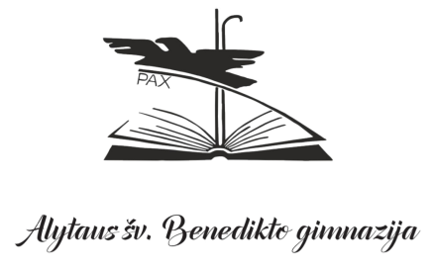

ONLINE RESOURCES

LOCAL PUBLIC LIBRARIES AND ONLINE DATABASES
(for all subject groups)
Name |  | Description | Link | Access
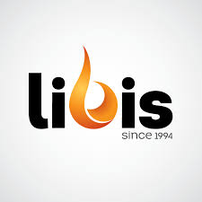 |  | This catalogue offers a convenient way to search library resources based on keywords, titles, authors and subjects. The needed resource could be booked in any Lithuanian library and send to the user to any place for agreed time period | https://ibiblioteka.lt/metis/ | The login details of public library membership could be used to login to the system
 |  | Fiction and non-fiction resources | http://www.alytus.mvb.lt/ | Public library membership
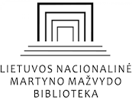 |  | Websites, databases and ePublications on different topics could be accessed | https://www.lnb.lt/en/ | Teachers and students login individually
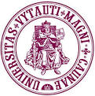 |  | Free databases, scientific resources | https://biblioteka.vdu.lt/duomenu-bazes/laisvai-prieinamos-duomenu-bazes/ | Teachers and students login individually
 |  | Free databases, scientific resources, e-publications | https://www.mruni.eu/lt/universitetas/biblioteka/duomenu_bazes/atviros_pareigos_db/ | Free access
 |  | Free database to search more than 670,000 electronic theses and dissertations (ETDs) from more than 25 universities worldwide | https://biblioboard.com/opendissertations/ | Free access
 |  | Online database with access to various scientific articles and resources. | https://www.researchgate.net/search | Free access
DICTIONARIES AND ENCYCLOPEDIAS
(for all subject groups)
 |  | General Lithuanian encyclopaedia. | https://www.vle.lt | Free access
 |  | General knowledge English-language online encyclopaedia | https://www.britannica.com/ | Free access
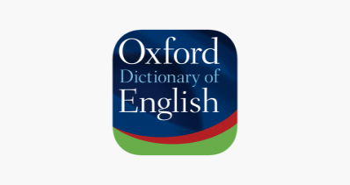 |  | The largest and most trusted free online dictionary for learners of British and American English with definitions, pictures, example sentences, synonyms, antonyms etc. | https://www.oxfordlearnersdictionaries.com | Free access
 |  | The most popular dictionary and thesaurus for learners of English. Meanings and definitions of words with pronunciations and translations. | https://dictionary.cambridge.org | Free access

DATABASES AND ONLINE RESOURCES BY IBDP SUBJECT GROUPS

GROUP 1: LANGUAGE AND LITERATURE
GROUP 2: LANGUAGE ACQUISITION
Name | Description | Link | Access
 | Ebooks. | https://books.google.com | Free access
šaltiniai.info | Interactive language and literature (Lithuanian) resources database. | http://www.xn--altiniai-4wb.info | Free access
 | Biographies, book reviews, poetry, essays. | https://www.rasyk.lt | Free access
 | Online literature for the student, educator, or enthusiast. The work could be found through the author index. There are over 3500 full books and over 4400 short stories and poems by over 260 authors, over 8500 quotes, and quiz system features over 340 quizzes. | http://www.online-literature.com/ | Free access
 | Project Gutenberg is a library of over 60,000 free eBooks. Choose among free epub and Kindle eBooks, download them or read them online. You will find the world's great literature here, with focus on older works for which U.S. copyright has expired. Thousands of volunteers digitized and diligently proofread the eBooks, for enjoyment and education. | https://www.gutenberg.org | Free access
 | Modern Lithuanian literature anthology. Visual and audio texts. Authors. Poetry. Excerpts. Videos. | http://www.tekstai.lt | Free access
 | Classical Lithuanian literature website | http://antologija.lt | Free access
 | Thousands of resources for both students and teachers of second languages, from basic vocabulary and grammar guides to advanced writing and conversation exercises. | https://www.thoughtco.com/languages-4133094 | Free access
GROUP 3: History, Economics and Geography
 | Free statistics, metadata, publications, etc. | https://ec.europa.eu/eurostat/data/database | Free access
 | Information about unrepresented and marginalized people worldwide and fundamental human rights. | https://unpo.org/members.php | Free access
 | Statistical data, metadata (Lithuania), eLibrary | https://osp.stat.gov.lt/temines-lenteles7 | Free access
 | Eldis supports free and open access to useful and relevant research on global development challenges | https://www.eldis.org/ | Free access
 | Academic journal covering articles from the middle-ages to the 21st century as well as a wide range of methodological approaches. | https://www.history.ac.uk/ | Free access
 | The UK’s largest digital research data in social sciences and humanities | https://www.data-archive.ac.uk/find/ | Free access
 | Alpha History is a free, ad-supported online textbook for history teachers and students. It spans twelve different historical periods or themes, with more under construction in 2019-20. Alpha History contains thousands of invaluable resources including topic summaries, documents, images, maps, timelines, biographical profiles and historiographical information, as well as a range of online activities | https://alphahistory.com | Free access
 | This archive of primary documents from World War One has been assembled by volunteers of the World War I Military History List (WWI-L). International in focus, the archive intends to present in one location primary documents concerning the Great War. | https://wwi.lib.byu.edu/index.php/Main_Page | Free access
(History) | BBC Programmes, a permanent rolling record of everything on BBC Television and Radio. Since October 2007 this site has created a permanent, findable web presence for every programme the BBC has broadcast, with some programmes being populated as far back as 1942. | https://www.bbc.co.uk/history | Free access
 | Digital Archive, international history declassified | https://digitalarchive.wilsoncenter.org | Free access
 | History resources | https://www.historytoday.com/ | History teacher has the login information
 | History resources | https://spartacus-educational.com/Jlow.htm | Free access
 | History resources | https://istorijai.lt | Free access
 | Publications on news, politics, business, finances, science, technologies | https://www.economist.com/ | Economics teacher has the login information
 | The magazine about Economics and Politics, Trends and Prospects for Active Members of the Society in Business, Politics, and Cultural Life | https://www.valstybe.eu/ | Printed version could be found in the school’s library
 | Offers the readers daily features that cover the most important developments shaping the global economy, politics and culture, often use cross-country comparisons to zoom in on what unites and divides countries, societies, economies and cultures. | https://www.theglobalist.com/ | Free access
 | Geography resources for students and teachers | https://www.nationalgeographic.org | Free access
 | Geography resources for teachers | http://www.geographyforgeographers.com/geography-resources-for-teachers.html | Free access
 | Geography Resources, Maps, & Facts for Students | http://www.studentguide.org/geography-resources-maps-facts-for-students/ | Free access
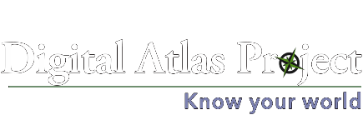 | Online atlas for students and teachers around the globe, searching for up-to-date world and regional maps, data, and visualizations for learning geography. | https://www.digitalatlasproject.net/home | Free access
 | Informative, authoritative and educational magazine which covers a wide range of subject areas, including geography, culture, wildlife and exploration, illustrated with superb photography | http://geographical.co.uk/magazine | Many resources are free to be used
 | Science, tech, math, humanities, languages resources | https://www.thoughtco.com/ | Free access
GROUP 4: Biology, Chemistry, Physics
 | MedlinePlus is a service of the National Library of Medicine (NLM), the world's largest medical library, which is part of the National Institutes of Health (NIH). The mission is to present high-quality, relevant health and wellness information that is trusted, easy to understand, and free of advertising, in both English and Spanish. Anywhere, anytime, on any device—for free. | https://medlineplus.gov/ | Free access
 | Explore scientific, technical, and medical research (articles, publications) | https://www.sciencedirect.com/ | Free access
 | Free statistics, metadata, publications, etc. | https://ec.europa.eu/eurostat/data/database | Free access
 | NSDL provides high quality online educational resources for teaching and learning, with current emphasis on the sciences, technology, engineering, and mathematics (STEM) disciplines. The NSDL collection contains structured descriptive information (metadata) about web-based educational resources held on other sites by their providers. These providers have contributed this metadata to NSDL for organized search and open access to educational resources via this website and its services. | https://nsdl.oercommons.org/ | Registration and membership is free
 | Over 4000 handpicked physics or browsed sites, physics experiments, the latest physics news | https://www.iop.org | Free access
 | Physics World represents a key part of IOP Publishing's mission to communicate world-class research and innovation to the widest possible audience. The website forms part of the Physics World portfolio, a collection of online, digital and print information services for the global scientific community. Physics World helps scientists working in academic and industrial research stay up to date with the latest breakthroughs in physics and interdisciplinary science, provides an international readership with a unique mix of daily news, opinion and analysis from an award-winning team of science writers and editors. | https://physicsworld.com/ | Free access
 | Provides scientific, technical, engineering, bioscience and medical research resources and news (articles, publications, databases, journals) | http://www.scicentral.com/index.html | Free access
 | Interactive simulation for science and maths | https://phet.colorado.edu/ | Free access
 | PraxiLabs makes virtual science labs accessible, usable, and affordable for educational institutions and schools. PraxiLabs not only provides an immersive virtual lab experience, but adds enriched content that provides students more understanding and knowledge. | https://praxilabs.com | Free access
 | Eldis supports free and open access to useful and relevant research on health issues | https://www.eldis.org/ | Free access
 | Coding and Computer Science Resources | Access via google.com — gettingsmart.com | Free access
 | Free resources for Computer science | https://www.hastac.org/blogs/shanelee/2014/09/25/best-free-resources-computer-science | Free access
 | Scientific material for students and educators (NASA missions, articles, TV broadcasts, galleries, etc.) | https://www.nasa.gov/audience/foreducators/computer-science-educational-resources.html | Free access
 | Discover magazine reports captivating developments in science, medicine, technology, and the world around us. Spectacular photography and refreshingly understandable stories on complex subjects connect everyday people with the greatest ideas and minds in science. | http://discovermagazine.com/ | Free access
 | Provides independent, unbiased coverage of science and give people the tools to evaluate the news and the world around them. | https://www.sciencenews.org/ | Free access
 | Products , the news and narratives for future science (articles) | https://futurism.com/ | Free access
 | Science and math, humanities and religion, or architecture and the arts, our in-depth articles | https://www.thoughtco.com/ | Free access
GROUP 5: Mathematics
 | Free math tutorials | http://patrickjmt.com/ | Free access
 | IB Maths question banks, practice exams, papers, videos | https://www.revisionvillage.com/ | Limited access
 | Games, animation and interactive tools to help middle schoolers with basic concepts. | https://www.mathsnacks.com/ | Free access
 | Free math tutorials, materials | https://ibmathsresources.com | Free access
 | Free math tutorials, materials | https://www.khanacademy.org/math | Free access
 | The website is is designed to help the struggling algebra student | https://www.purplemath.com/ | Free access
 | The website offers free lessons in advanced math subjects including calculus, statistics, and trigonometry. | https://hippocampus.org/ | Free access
 | NSDL provides high quality online educational resources for teaching and learning, with current emphasis on the sciences, technology, engineering, and mathematics (STEM) disciplines. The NSDL collection contains structured descriptive information (metadata) about web-based educational resources held on other sites by their providers. These providers have contributed this metadata to NSDL for organized search and open access to educational resources via this website and its services. | https://nsdl.oercommons.org/ | Registration and membership is free
 | Science and math, humanities and religion, or architecture and the arts, our in-depth articles | https://www.thoughtco.com/ | Free access
 | Free statistics, metadata, publications, etc. | https://ec.europa.eu/eurostat/data/database | Free access

